Network Flow
A flow network G = (V,E) is a directed graph in which each edge (u, v) $∈$ E
has a nonnegative capacity c(u, v)$≥$ 0. We further require that if E contains
an edge (u, v), then there is no edge (v, u) in the reverse direction. If (u, v) ∉ E, then for convenience we deûne c(u, v) = 0, and we disallow self-loops. Each flow network contain
two distinguished vertices: a source s and a sink t.
A flow in G is a real-valued function f : V X V$→$ R that satisfies the following two properties:
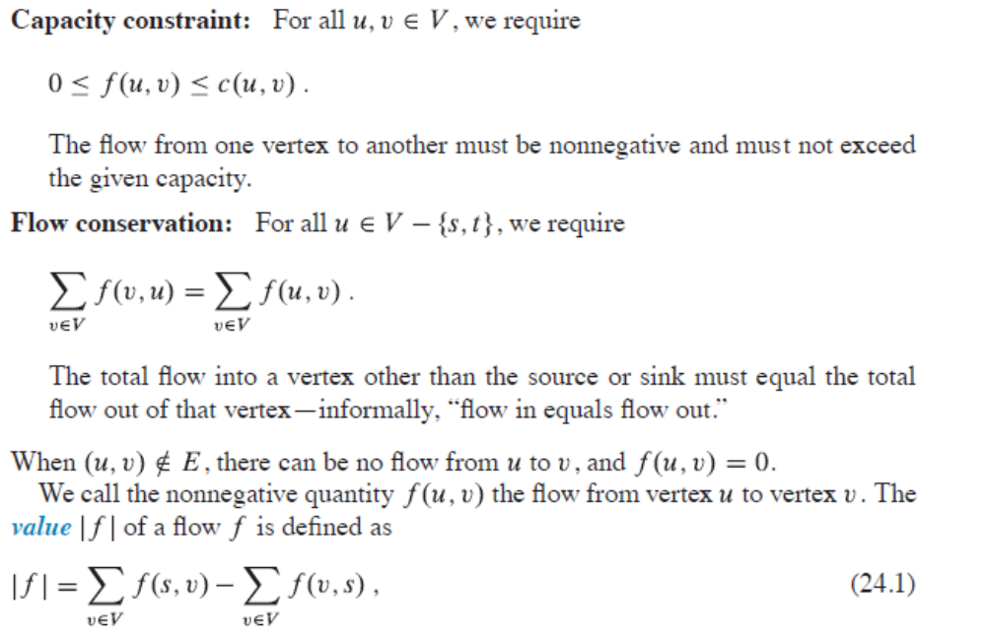
Residual networks
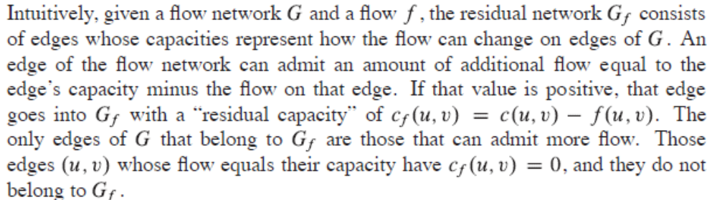
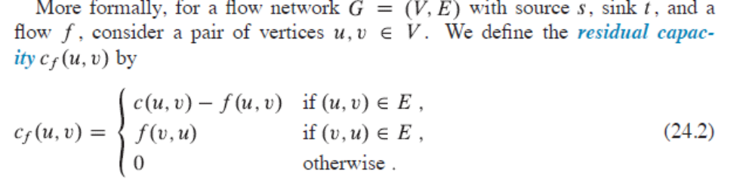
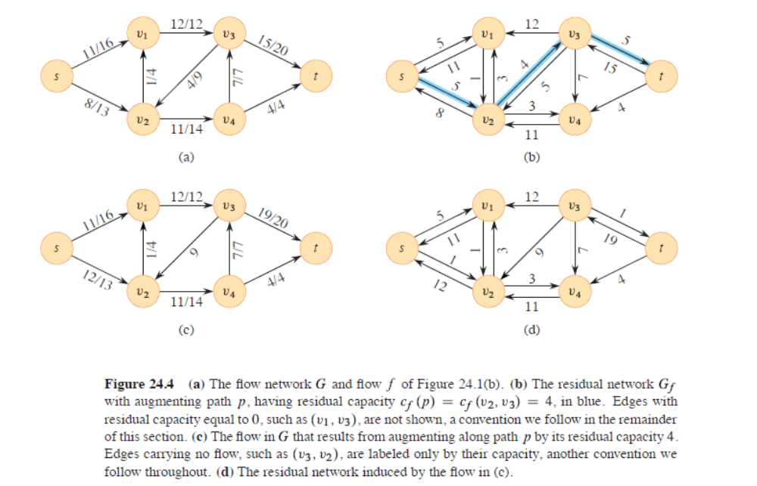
Augmenting paths
Given a flow network G = (V, E) and a flow f , an augmenting path p is a
simple path from s to t in the residual network G_{f}. By the definition of the residual
network, the flow on an edge (u, v) of an augmenting path may increase by
up to c_{f} (u, v) without violating the capacity constraint on whichever of (u, v)
and (v, u) belongs to the original flow network G.
The maximum amount by which we can increase the flow on each edge in an augmenting path p the residual capacity of p, given by
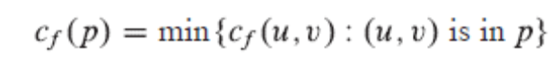
Cuts of flow networks
A cut .(S; T) of flow network G =(V;E) is a partition of V into S and
T = V - S such that s $∈$ S and t $∈$ T .
If f is a flow, then the net flow f (S; T) across the
Cut (S, T) is defined to be
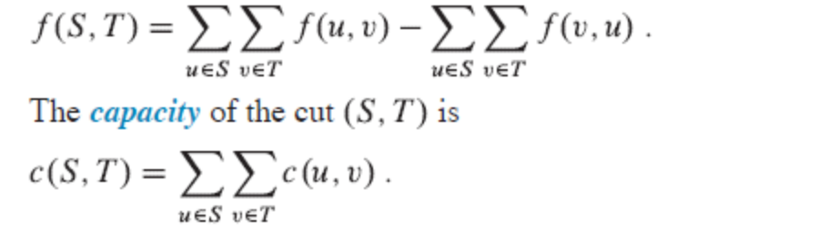
A minimum cut of a network is a cut whose capacity is minimum over all cuts of
the network.
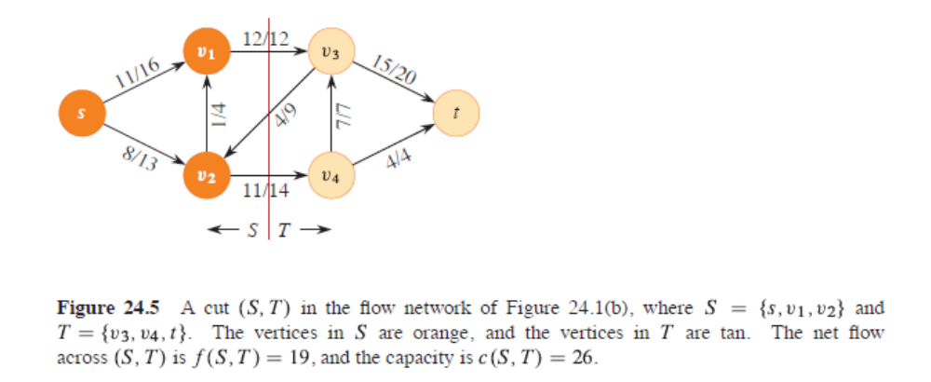
Max-Flow-Min-CutTheorem
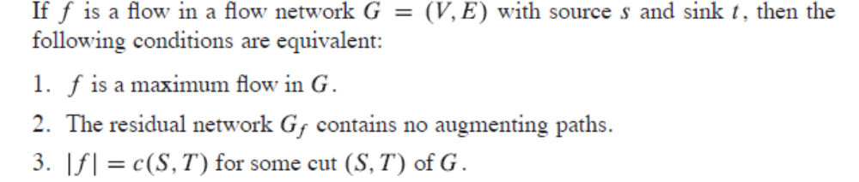
Ford-Fulkerson algorithm
